Chapter 1:

What Is ProxyMITY?

This chapter is intended to give you broad overview of Multimedia Integration tool called ProxyMITY and what you can accomplish using it. Our goal is to explain how the features in ProxyMITY help you create dynamic, rich-media lectures-ones that let you go beyond using simple text and images.

ProxyMITY lets you share your lecture with others through the web, through institute intranet or through a third party e-service provider. You can easily incorporate audio, video and still images with your lecture presentation slides to create dynamic, distributable, rich media lectures.

What can I do with ProxyMITY ?

You can install and run ProxyMITY on a computer that is running the Microsoft XP or Ubuntu operating system, Java JRE 1.6. or above. ProxyMITY is standalone application that lets you take your slides and synchronize them with video already recorded on your computer. Furthermore you can add still images to your presentations.

The final product is a rich-media presentation of lecture that you can distribute on institute intranet site, on a CD or on website so students, teachers, or anyone with web browser can watch them.

Working with ProxyMITY, you can create a variety of lectures based on your specific needs. Later in this chapter, you will see a list of different scenarios in which you might use ProxyMITY.

Figure 1-1 shows a lecture that is being edited in ProxyMITY.

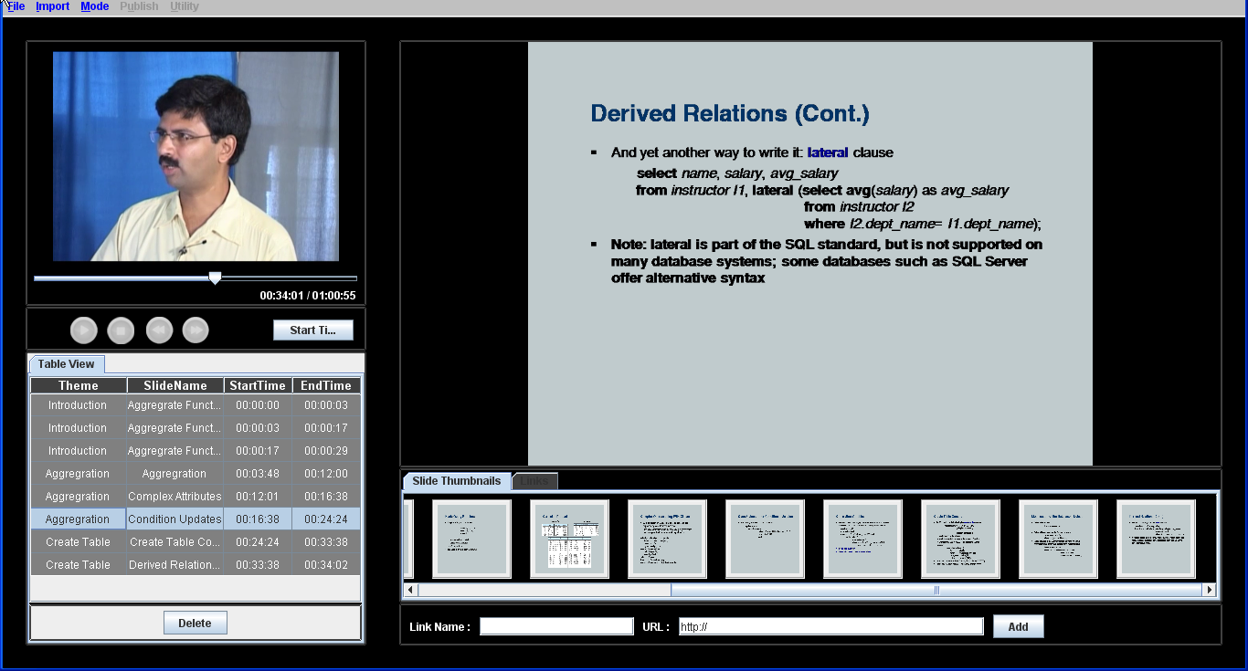

**Figure 1-1 Editing lecture in ProxyMITY**

**Working with ProxyMITY**

Before you start working with ProxyMITY and this book, it’s helpful to know that features are included in ProxyMITY and where they are discussed in this book. The following section is designed to do just that.

**Getting Content into ProxyMITY**

The first task is to bring digital media files into your ProxyMITY Project. The files that you can use in your projects can include video, still images. Because you can import a wide variety of digital media file formats, you will be able to use many of your existing still images, video files, or slides.

**Editing in ProxyMITY**

After you have imported digital media files you used in your lecture, you can begin synchronizing them in your project. You start by playing your lecture video, select the appropriate slide or image and adding start time, end time to it.

To help your student understand the topics discussed in your lecture, you can create themes. Themes in your project are much like the **Table of Contents** you see in a book; it provides a way for your students to see the topics or subjects that will be discussed. Just like a table of contents in a book lists page numbers for chapters or topics, the table of contents for your lecture contains links to a specific topic or part of your lecture. This way, viewers can simply click a link to go to that part of the lecture. When they click a table of contents link, they will go to the corresponding video, image, or slides that are contained in that topic.

In addition to synchronizing of slides with video, you can enhance your video lecture by adding website links or URL to each slide.

**Synchronizing Your Presentation**

You can choose to synchronize existing video files with your slides. This is an important feature of ProxyMITY because it lets you take different digital media files, such as video, still images, and slides, and then quickly synchronizes them to create a rich-media lecture presentation.

In addition to synchronizing existing video files with your slides, you can add extra website links about each slide.

**Previewing Your Presentation**

As you work on your project in ProxyMITY, you can preview it to see how the presentation will appear after you publish it. By previewing, you can get a sneak peek of your project before publishing it to a local computer.

**Publishing Your Lecture**

When you have finished editing your project, you are then ready to publish the lecture. When you publish the project as a complete lecture, all of the digital media in your project, including any video files, slides, and images, is compiled into one final lecture. You can then take the final lecture and the files contained in it and publish it to a local computer. It can be distributed by the means of compact Disk, Pen Drives etc.

Chapter 2:

The ProxyMITY

Interface

The ProxyMITY user interface is designed to help you immediately start making lectures. The basic elements of the user interface include menus, buttons and slide editing table.

This chapter will give you a quick introduction to the ProxyMITY interface.

**Using the Menu**

Figure 2-1 shows the New Project command being selected from the File menu.

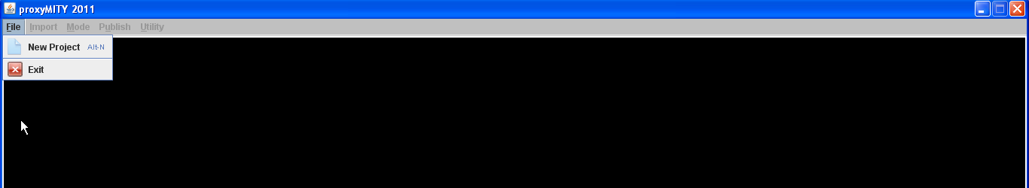

**Figure 2-1** selecting the New Project command

The following sections provide brief descriptions of menu commands.

**File Menu**

The following are the options available under **File Menu**.

* **New** Use this command to start a new project. When you use this command to create a new project, the thumbnail box , video box and slide table are empty. You can then import existing digital media files, and synchronize them.
* **Exit Application** Use this command to exit the proximity application.

**Import Menu**

The Import menu provides commands that help you import your existing slides and video on your computer into your project.

* **Import Main Video** Use this command to import the existing lecture video on your computer to your project. Once the video is imported a message box will be displayed stating that a media file has been added.
* **Import Images/Videos** Use this command to import converted slides images into your project. Once the slide images are imported they will be displayed in thumbnail box.

**Mode Menu**

The Mode menu helps you to switch between lecture Project mode and Preview mode.

* **Preview Mode** Use this command to switch from exiting editing mode to preview mode to preview your lecture to see how your project would look after publishing.

All other menu list would get invisible once you click on preview menu.

* **Project Mode** Use this command to switch from preview mode to project mode to continue working on the same project.All other menu list would get visible on clicking project mode.

**Utility Menu**

The Utility menu helps you to use various utilities integrated in ProxyMITY.

* **Video Convertor:** If you want to convert from one format to another, trim/split videos, convert mp4 to mp3 then you can click on Video convertor options.

**Publish Project Menu**

The Publish Project Menu helps you to publish your project in Desktop format i.e. jar file.

* **Desktop** : When project is publish in this format all the required files and time information will be copied to your destination folder in the form of XML , now you can view your lecture on desktop as separate application.

**Using options:**

Media player in Media box lets you play lecture video of the project. It provides a way for you to see slides synchronized with the video and their time information on progress bar of the media player.

Below media player is a series of buttons. These buttons functions just like any other media player button.

* **Play** : Use this button to play the video in media player.
* **Pause**  : Use this button or pause the video in media player.

Figure 2-2 shows the control buttons.

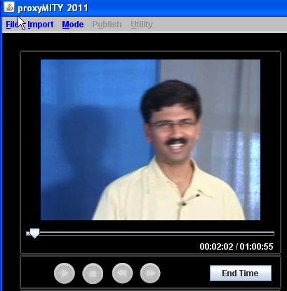

**Figure 2-2:** Media Box.

**Using Imported Media Box**

Below figure shows Preview Media Window and Thumbnail box.

When you import slides and videos from your computer to your project, these imported media are displayed on Thumbnail box.

Thumbnail box helps you to scroll and preview your slides and videos which will be required for the project. Thumbnail box provides preview media window where the slide or video is displayed when you select its thumbnail.When you move mouse over the thumbnail of the slide it scales up with red bounding box around it and name of the slide below. Below the Thumbnail box, there is one link name and link URL is provided. User can enter Link name and link URL and click on Add buttons. User can add any number of links.

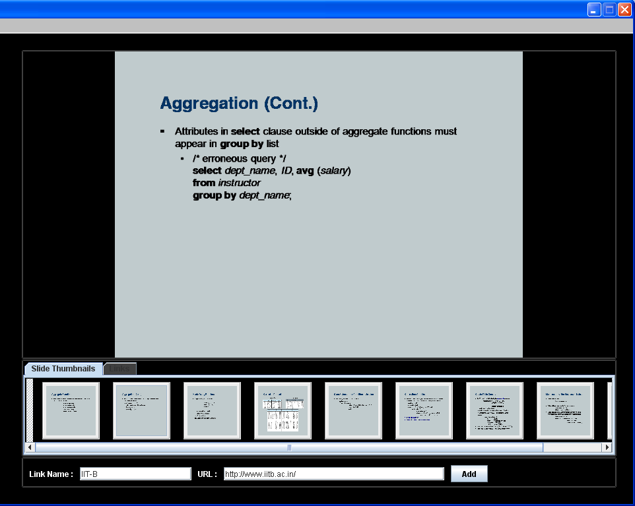

**Figure 2-4 : Imported Media box**

**Using slide Information Table**

When you select the slide from thumbnail box and synchronize it with lecture video, its information is displayed on slide information table.

Slide information table shows the slides used in project and their relative information. This table shows following information about slide

* **Theme Name** : Theme associated with this slide. Theme in ProxyMITY means topics contain in a lecture. Theme Name is editable by double clicking on itself. Theme in ProxyMITY are to help your student understand the topics discussed in your lecture. It provides a way to divide a lecture into small topic or subject. Each slide should be assign to one and only one theme of lecture else it will be assign to default theme of the lecture.
* **Slide Name** : Name of slide which will appear in lecture’s tree view after publishing the project. Slide Name is editable by double clicking on itself.
* **Start Time** : Time at which this slide will be displayed relative to video. Start Time is editable by double clicking on itself.
* **End Time** : Time at which this slide will be removed relative to video. End Time is editable by double clicking on itself.
* **Delete Slide** button : Use this button for removing slide and its information from the slide table, but slide will be available in thumbnail box.

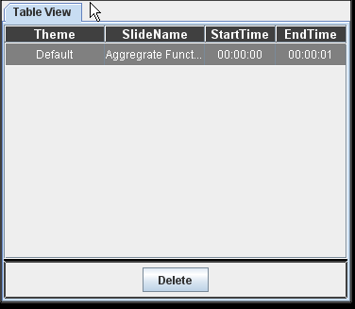

**Figure 2-5 : Slide Information Table**

Theme in ProxyMITY are to help your student understand the topics discussed in your lecture. It provides a way to divide a lecture into small topic or subject. Each slide should be assign to one and only one theme of lecture else it will be assign to default theme of the lecture.

Theme Table consist information regarding Theme used in lecture. It gives list view of theme created for the particular lecture.

Chapter 3:

Starting a

New Lecture

Now that you are familiar with ProxyMITY interface, you are ready to create your own lecture. The first step is to start ProxyMITY and begin your new project.

In this chapter you will see how to build a project from scratch by starting with blank project.

Creating New Project

**Step-by-Step: Creating new project**

1. Open ProxyMITY application.

2. Go to File menu and choose New Project

Once you select New Project, slide information table along with few buttons appears on screen, same as shown in Figure 3-1.

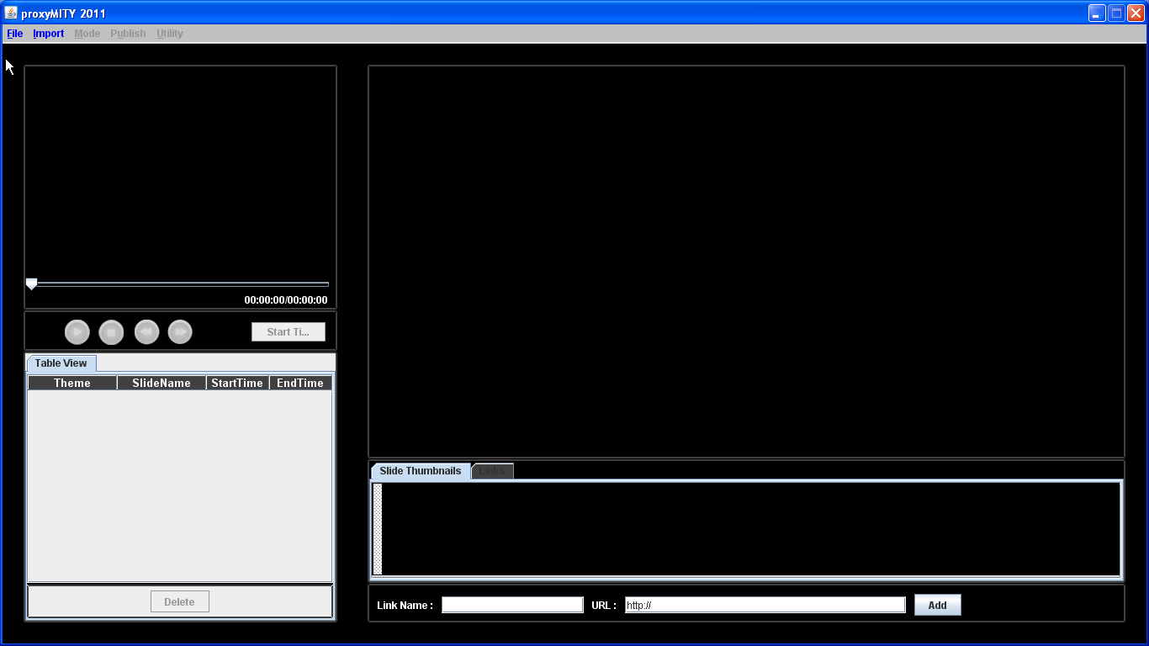

**Figure 3-1:** New Project without any content.

Adding Main Menu

You can add lecture video already existing on your computer. ProxyMITY supports almost video formats.

**Step-by-Step : Adding main video**

1. Go to Import menu

2. Select Import Main Video

3. Locate and select the video file you want to import.

Once you import video a **message box** containing the video name would be displayed.

After adding video to your project now you are ready to add slides.

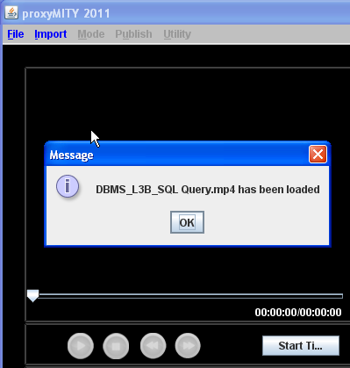

**Figure 3-2:** Imported main video displayed in Media box.

**Adding Slides and Videos**

Once you have added video to project now you can added slides and videos to project. Slides in ProxyMITY are still images of ppt slides.

ProxyMITY support following image formats .jpg, .jpeg, .png, .bmp and .tiff only.

**Step-by-Step : Adding slides**

1. Go to Import menu.

2. Select Import Image.

3. Locate and select the image files you want to import.

You can import multiple image files at one time. To do this, press the Ctrl key, and then click each file you want to import into your current project. If multiple files are listed contiguously in Import File dialog box, you can press the Shift key, click first file you want to import, and then click the last file in that you want to import.

**Step-by-Step : Adding videos**

1. Go to Import menu.

2. Select Import Videos.

3. Locate and select the video files you want to import.

You can import multiple video files at one time. To do this, press the Ctrl key, and then click each file you want to import into your current project. If multiple files are listed contiguously in Import File dialog box, you can press the Shift key, click first file you want to import, and then click the last file in that you want to import.

Once you imported slides & video into your project, slides will be displayed in thumbnail box as show in figure 3-3.

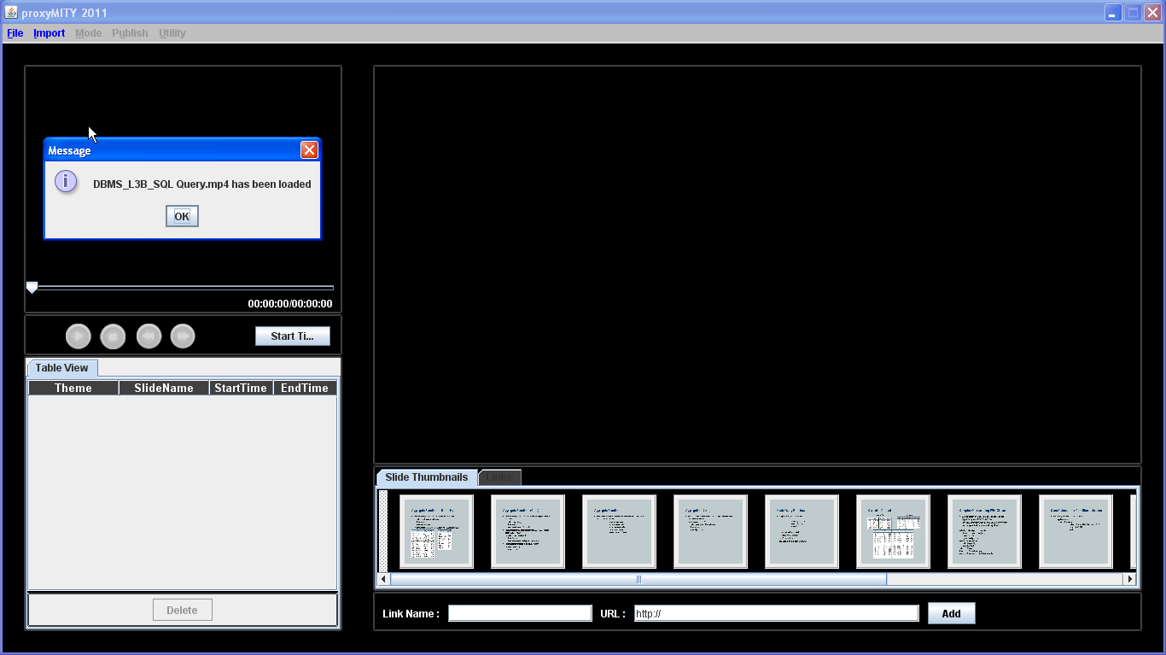

**Figure 3-3:** Imported slides displayed in thumbnail box.

**Synchronizing Slides**

Now that you have all required content like video and slides imported into your project, you can now start using them and synchronizing them with video. With this feature, you can synchronize your slides so a specific slide corresponds to the correct part of your video content.

**Step-by-Step: Synchronizing Images with Main Video**

The following procedure describes the step-by-step process for synchronizing image slides with video only.

1. To begin synchronizing, select the slide from thumbnail box by clicking on it, once you click on thumbnail slide will be displayed in preview slide window as shown in

Figure 3-4. and then click Play button of media player, video starts to play.

1. Click on **Start Time** button when you think is the right time for selected slide to be displayed in lecture.
2. Click **Stop Time** button when you think is the right end time for selected slide. Start time and Stop time is timing information associated with slide which enable ProxyMITY to display corresponding slide at its start time relative to video time and stop displaying slide when slides corresponding stop time is reached. Hence that slide will be visible only in that time duration while video is playing.
3. Once you clicked on stop time button, time information of that slide is displayed in Slide Information Table.
4. Similarly use same procedure for synchronizing other slides.
5. The Default Theme name is Default. One can edit and update Theme name, Start Time , End Time any number of times.

**Step-by-Step: Synchronizing Videos with Main Video**

The following procedure describes the step-by-step process for synchronizing video slides with video only.

1. To begin synchronizing, select the slide from thumbnail box by clicking on it, once you click on thumbnail video will be displayed in preview media window as shown in Figure 3-5. and then click Play button of media player, video starts to play.
2. Click on play button on preview media window to start the video slide to play
3. Click on **Start Time** button located below Play button when you think is the right time for selected video slide to be displayed in lecture.
4. Click **Stop Time** button when you think is the right end time for selected slide.

When you click on stop button both the main video and video slide will be paused and timing information will be stored in slide information table.

1. Once you clicked on stop time button, time information of that slide is displayed in Slide Information Table.
2. Similarly use same procedure for synchronizing other video slides.

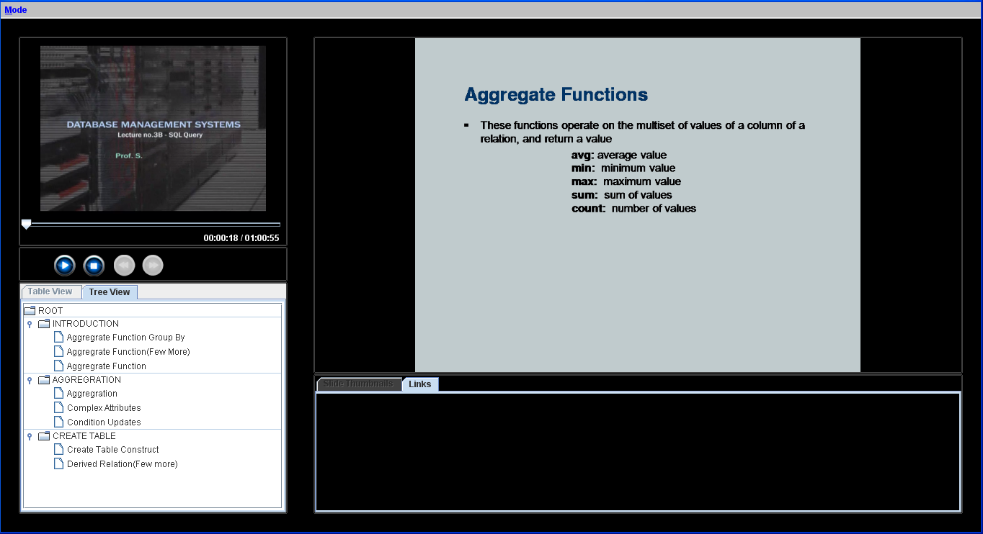

**Figure 3-4:** Selected slide in preview slide window.

**Removing Slide**

Sometimes it happen that slide which you synchronized earlier but now you don’t want that slide to be in your lecture. You want to remove that slide.

**Step-by-Step: To remove slide from slide information table and Project.**

1. Select the slide from slide information table which you don’t require by clicking on it.
2. Below Slide information table you will see Delete Slide button, click on it to remove unwanted slide.
3. The unwanted slide and its associated data will be removed from slide information table but the slide will be available in Thumbnail box in-case of use in future.

**Adding Themes**

Themes are lecture divided into sub-topics or chapter, each theme represents one topic in lecture and each theme consists of one or more slides. So from student point of view it will be better for him/her to directly go and view the topic of interest just by clicking on that theme other than viewing the whole lecture.

So let us now learn how to add themes to your lecture and add corresponding slides to each theme.

**Step-by-Step : Creating themes and assigning a theme to each slide.**

1. Go to theme table and click on add Theme button, this action will open an add theme dialog box.
2. Dialog box contains Name field and Ok and Cancel button, Enter desired name of theme and click on OK button to proceed or else click cancel.
3. Once the theme name is entered and clicked ok, entered theme is displayed on theme table. Now you are ready to add slides to respective theme.
4. Each slide can be assign only one theme. To assign a theme to a slide follow these steps :
   1. Select slide from slide information table.
   2. Select theme from theme table.
   3. Once you select theme from theme table you will notice that other buttons of theme table are enabled now.
   4. Click on Assign Theme button to assign a slide to theme.
   5. Once you have done this you will notice that slide theme information in information table has been updated for that slide. Its value in Theme Name column has been updated to Theme assigned to it.
   6. Follow the same step for assigning themes to different slides of lecture.
5. To delete the theme, select the theme from theme table and click on Delete Theme Button, Once the theme is deleted slide assign to this theme will be assigned to default theme. Which you will notice in Slide Information table.

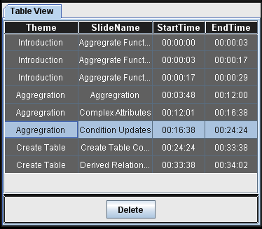

**Figure 3-8:** Slide Information table updated after theme assigned to a theme

**Previewing Lecture**

Now that you have synchronized your slides with video and add Themes to your lecture let us look now how preview lecture looks.

**Step-by-Step: Previewing lecture and exploring it.**

1. To preview your lecture go to Mode menu and select Preview Mode.
2. You will notice window similar to figure 3-9, which displays preview mode of Project.
3. The window consists of slide box on left to display slides, media player on right to play the lecture video and Themes tree view to navigate through the lecture. The another empty box is for Slide Description which we will learn in next chapter.
4. Use play button to play the video as the video plays the slide in slide box changes respective to its start time and end time assigned in Project mode.
5. The theme tree view is to navigate through different part of lecture and slides. If you click on ‘arrow’ symbol preceding the theme name it expands and displays slides under it. As shown in figure 3-10.
6. You can click on interested slide and move on to the desired part of lecture.
7. To switch back to Project mode go to Mode menu and select Project Mode you will be redirected to project mode where you can continue with your lecture synchronization.



**Figure 3-9 :** Project in Preview Mode

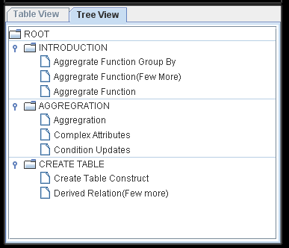

**Figure 3-10:** Tree view displaying Themes and Slides under it.

**Publishing the Project**

Up to this point, your focus has been on creating the project. You have synchronized your slides with video, added additional description to slide. Now you probably cannot wait to show it to someone else. But how can you show your work to people outside of your school?

To get your presentation to its intended audience, you use some means of distribution. In ProxyMITY this is called Publishing. Publishing your lecture means making it available to your audience.

ProxyMITY includes this feature which makes it easy to package your finished project and make it available for viewing from a CD, a shared network location, a intranet or the internet. It automatically creates all the files necessary for viewing it, and copies each file to appropriate destination.

In ProxyMITY Desktop Publishing can be made.

**Desktop Publishing**

In Desktop publishing, ProxyMITY creates all the necessary files and copies each file to destination folder selected by you. In desktop publishing enables you to make your project available for audience in form of jar file with all appropriate project data.

For audience to view lecture publish by Desktop mode, it necessary that their system must have java install.

**Step-by-Step : Publishing project using desktop publishing**

1. Go to Publish Project menu.
2. Select Desktop.
3. Select destination folder where you want to copy all your files.
4. Application will start copying all the project related files , it will take some time depending upon number of slides and size of video to copy. Then copy plugins folder and image folder to the destination folder.
5. Once copying is done you can go to the final published folder and click on .jar file
6. Now you can view your final publish lecture.
7. To distribute the lecture on to CD you have to copy the whole folder on to CD.

Desktop Publishing final product is similar to Previewing of the lecture in Preview mode with all the features and animations. As shown in figure 3-11.

